**Module 4) CSS and CSS 3**

1. What are the benefits of using CSS ?

Css is used for styling purpose are as follows-

1.Device friendly-with the help of media query tag or responsive we can make our file device friendly.

2.Easy formatting changes--if we want to change particular section of our code then we can do it easily.

3.Better UI/UX-- with the help of css we can make visual apparence of our css look good.

1. What are the disadvantages of CSS ?

Browser compatibility:-Cascading style sheets is platform dependent it requires some specific browser for running .

Complexity:- css is a bit complex in terms of responsiveness and code.

Security:- CSS is lacking in terms of security.

1. What is the difference between CSS2 and CSS3?

Difference between css2 & css3 are:-

1. Browser suppoet
2. Responsive design
3. Animation & 3d
4. Speed
5. Color scheme:-HSL,RGBA,HSLA
6. Name a few CSS style components

Css style components are:-

1. Selector:-ID or class selector
2. Properties:-color,font-size,background-color,border
3. Values
4. Pseudo-class ::hover,:class
5. 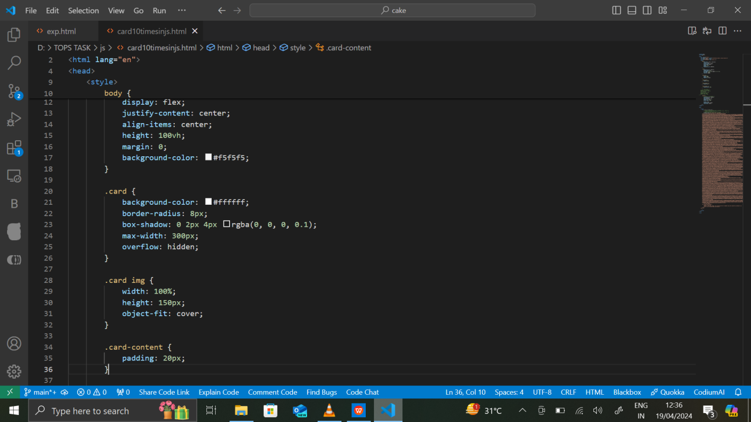
6. Media query:- media screen (min-width:12px) and (max- width:133px)
7. How can the background color of an element be changed?

We can change the background color of an element by

Class or id name{

Background color:yellow

}

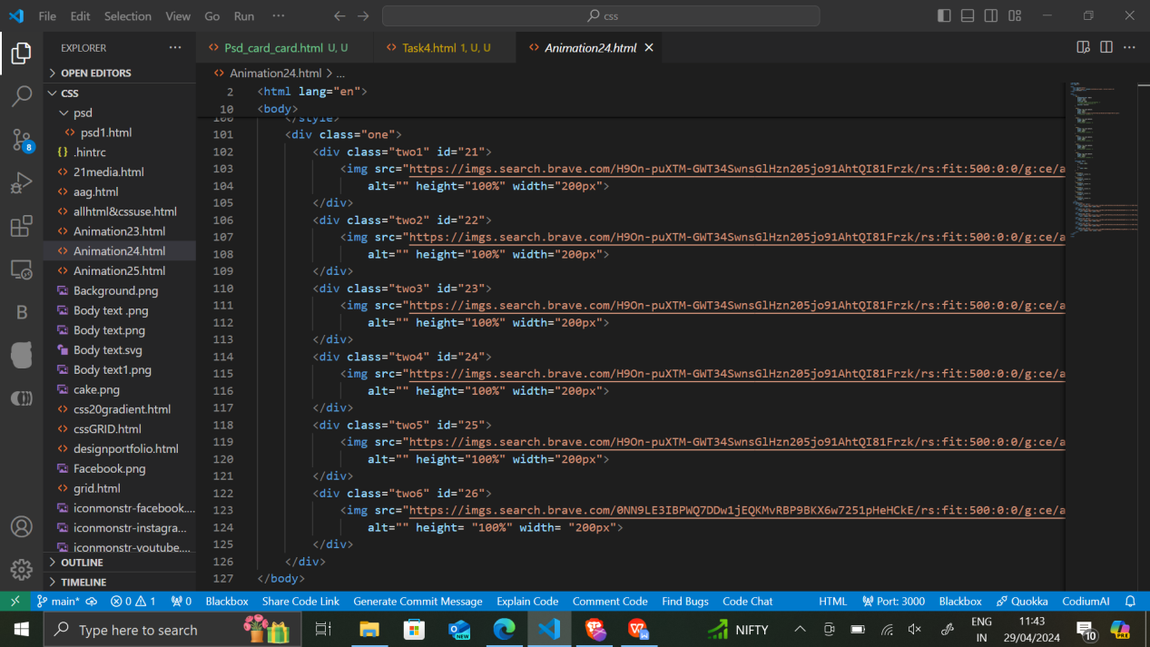

1. How can image repetition of the backup be controlled?

Image repeation can be controlled by

Background-repear

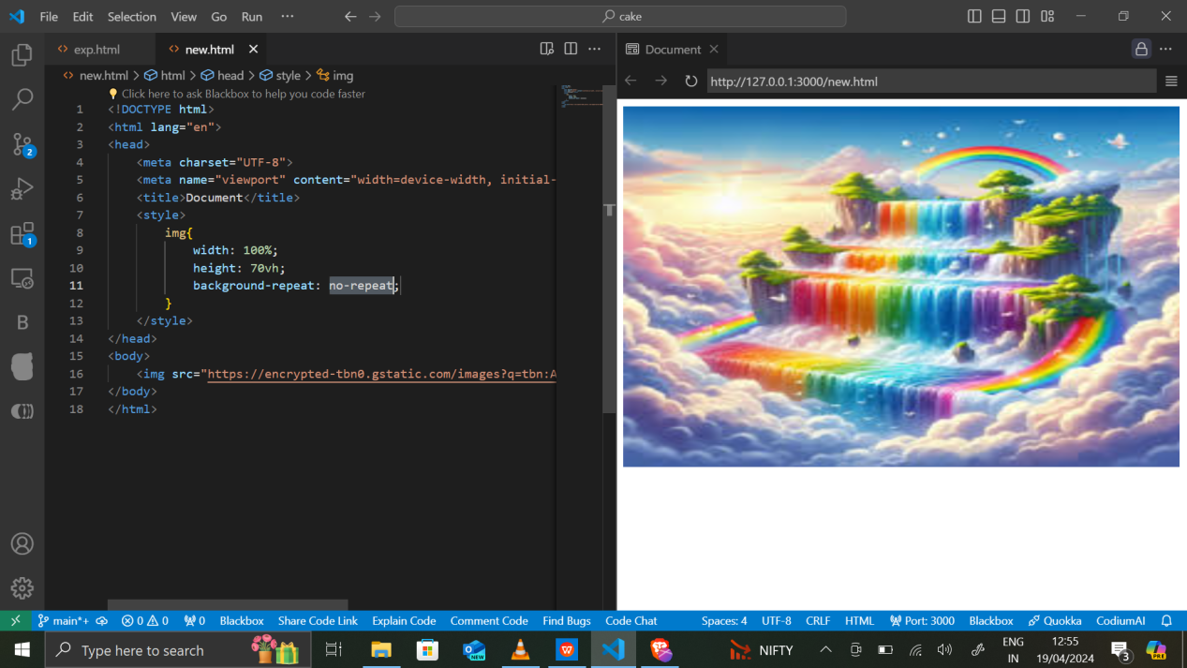

1. What is the use of the background-position property?

The background position property is used to fix the position of background image, background-color or background: url() to the top,bottom left,right.

1. 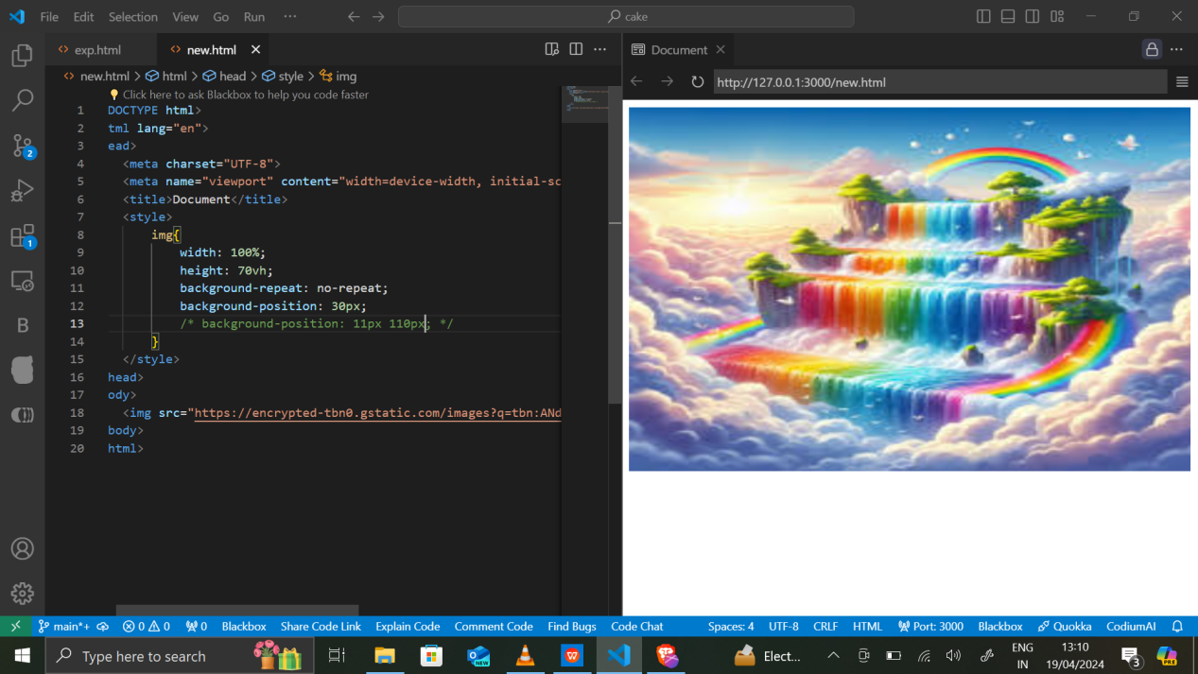
2. Which property controls the image scroll in the background?

Background-attachment:fixed; is the property which controls the image scrolling in the background

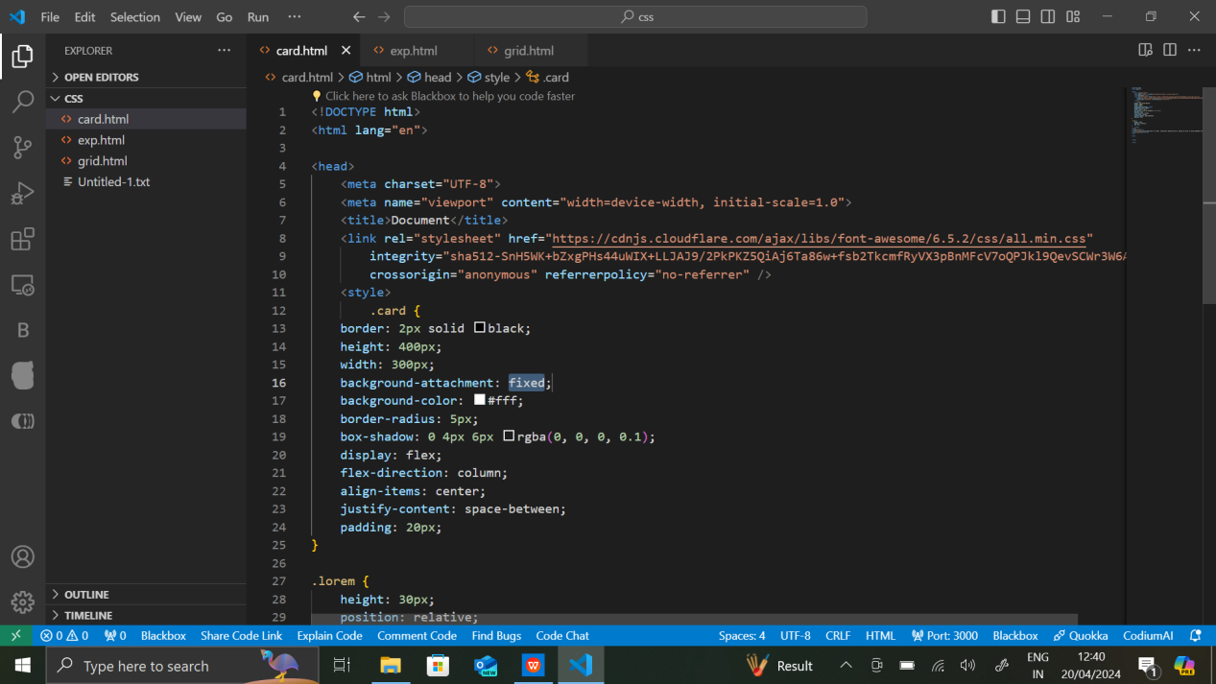

1. Why should background and color be used as separate properties?

Background and color are 2 different things for example

If we write background-color:yellow this will effect the whole page,whereas the color property will effect only particular section of a,input,placeholder,etc.

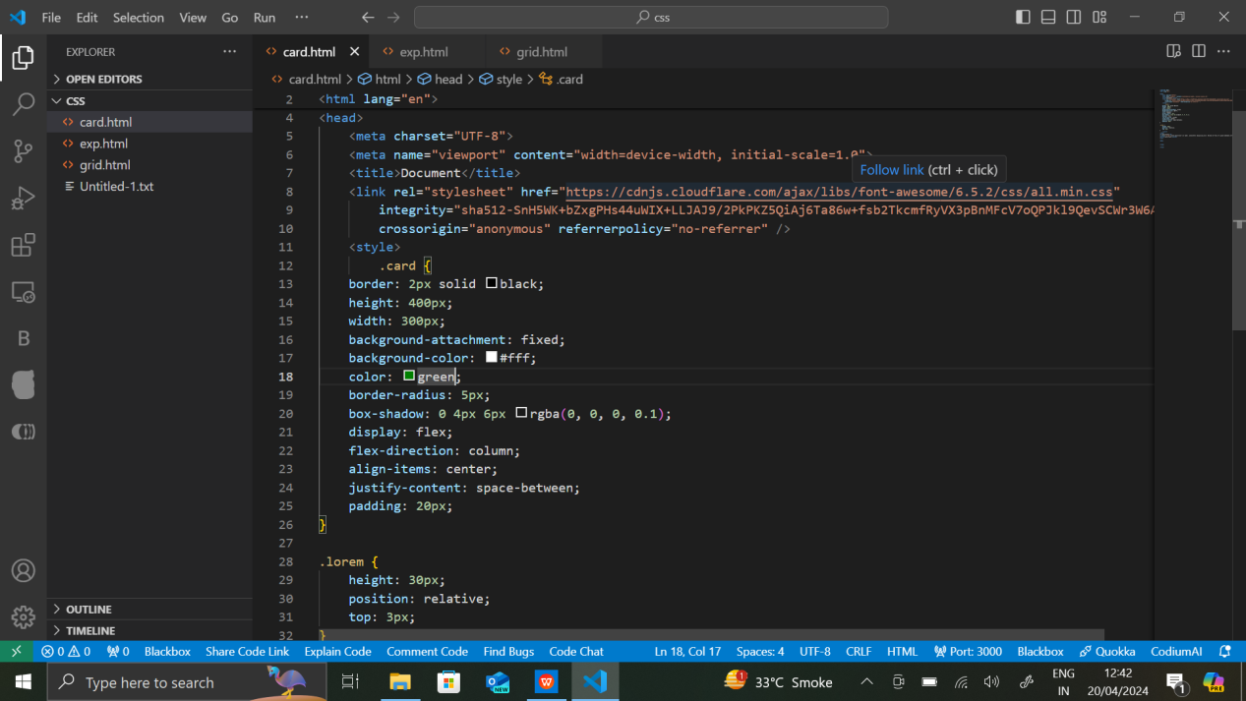

1. How to center block elements using CSS1?

We can center the element by using align-item:center

Or justify-content:center;

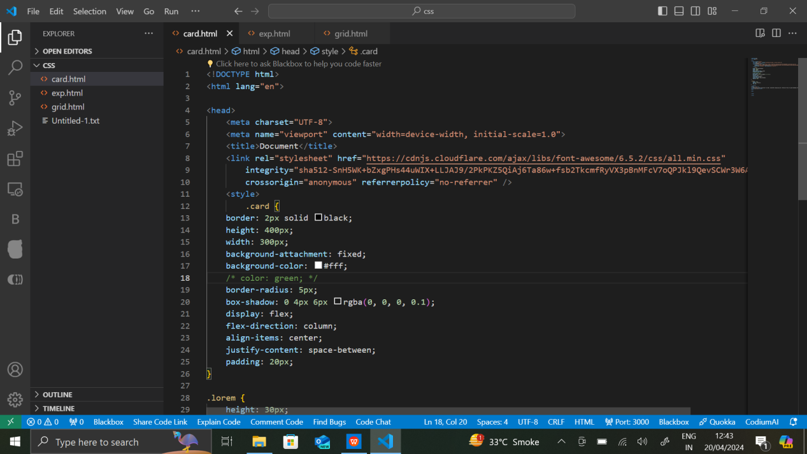

1. What are the ways to integrate CSS as a web page?

3 ways to integrate css are

1. Inline css
2. Internal css

iii.External css

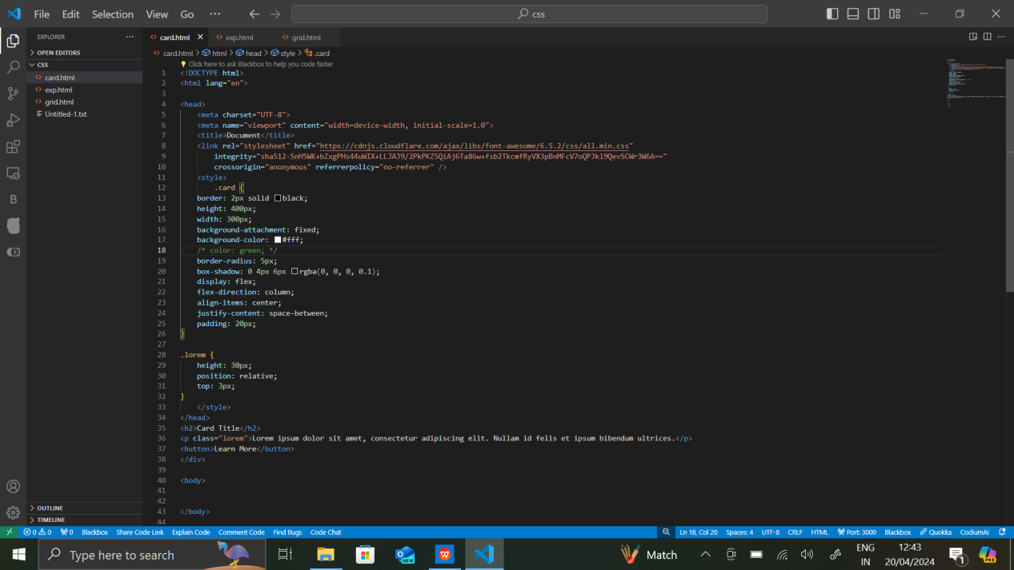

1. What is embedded style sheets?

Embedded style sheets also known as inline css,and it has highest priority of all css.

Example <style>Hello world</style>

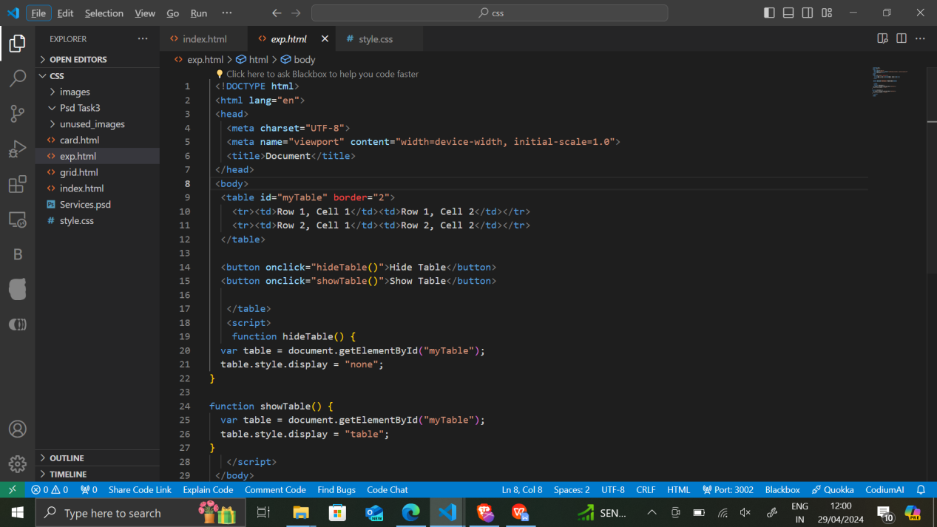

1. What are the external style sheets?

External css is the external page with .js extension where we write our javascript code and we link it,in our html code using <script src=”.js”></script>

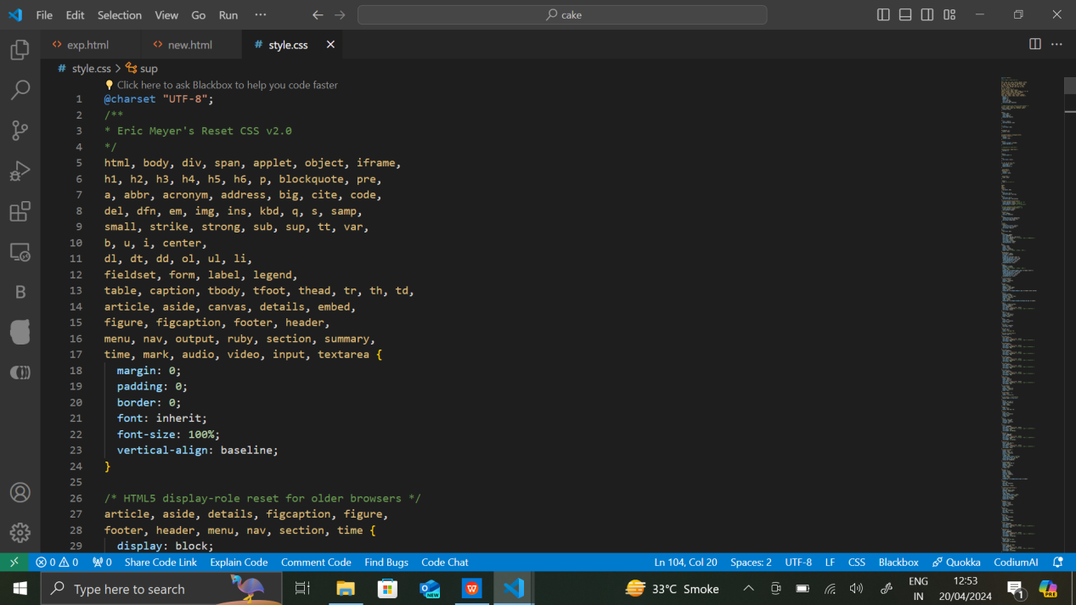

1. What are the advantages and disadvantages of using external style sheets?

Disadvantages are:-

Rendering Delay:-The page cannot be loaded untill the external css is loaded

Increased download time:-if the file has multiple css files linked to html file then it increases its download time which will affect its overall performance

Advantages are:-

Clear file and clear structure.

Easily reuse-able

1. What is the meaning of the CSS selector?

A way to style our page with different features called css selectors. Css selectors is of 5 types:-

1. Class
2. Id
3. Element
4. Group
5. Universal
6. 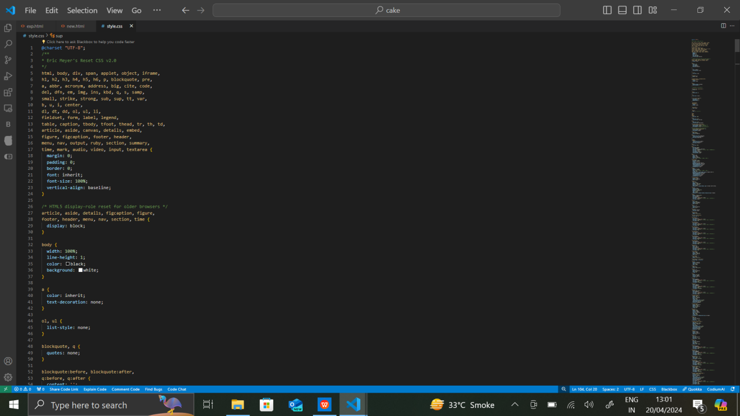
7. What are the media types allowed by CSS?

Media query is the only type allowed in css.

